


Comparative Efficacy of Various Sealant Materials in Preventing Dental Caries in Children and Adolescents

MODULE: DEN840 (62930)
Research Dissertation 2025
Submitted to Ulster University as Part of Completion of the Award of
MSc Advanced General Dental Practice

Student ID Number: B00996616

Word Count: 6260
Submission Date: August 11, 2025

Supervisor

Dr. Soher Nagi Jayash
(BSc, MSc, PhD, FHEA)
Visiting Lecturer, College of Medicine and Dentistry,
Birmingham,
United Kingdom
Core Scientist, Roslin Institute,
University of Edinburgh, UK

Declaration

To Whom It May Concern:

I hereby declare that the dissertation titled:
Comparative Efficacy of Various Sealant Materials in Preventing Dental Caries in Children and Adolescents

Which I am submitting for my degree of Master of Science degree, is:
(1) Not one for which another degree has been or will be conferred by this or any other university.

I also confirm that
(2) The work of this thesis and its composition are my own.

Finally, I certify that:
(3) The work of this dissertation has not been presented to any other institution.

Dedication

I dedicate this dissertation with deepest love and respect to the cherished memory of my late father, Mr. S. Arun, whose blessings, strength, and inspiration continue to guide and motivate me in every step of my life.
I offer this work in honour of my mother, Mrs. C. Pramila, whose unconditional love, sacrifices, and unwavering support have been the foundation of all my achievements.
To my brother, Mr. S. A. Tharun, I express my heartfelt gratitude for his constant encouragement, understanding, and belief in me, which have been a source of strength throughout my academic journey.
I extend my sincere thanks to my friends and well-wishers for their continuous encouragement and prayers, which have inspired me to strive harder and achieve my goals.
To all who have supported, guided, and motivated me during this journey, I offer my deepest gratitude and respect.
To all who have supported and inspired me on this journey, I offer my eternal gratitude.

Acknowledgement
I would like to express my sincere gratitude to Ulster University for providing me the opportunity to pursue my MSc in Clinical and Diagnostic Oral Sciences. I am deeply thankful to all the lecturers and staff at the School of Dentistry for their guidance and for making this academic journey an enriching and rewarding experience.
My heartfelt thanks go to my supervisor, Dr. Soher Nagi Jayash , for her invaluable guidance, constructive feedback, and continuous support throughout my research. Her expertise, motivation, and encouragement have been instrumental in the completion of this dissertation.
Finally, I extend my deepest appreciation to my family and friends for their unconditional support, patience, and encouragement, which have been a constant source of strength throughout this endeavour.

Table of contents
Contents
Declaration 2
1. Abstract 5
2. Introduction and Rationale 5
2.1 Research question 6
3. Background 6
3.1 Aetiopathogenesis of pit and fissure caries 7
3.2 Applications of Different Sealants 7
3.3 Study aims and objectives 10
4. Methodology 12
4.1 Study design 12
4.2 Literature Search 12
4.3 Mesh term used. 12
4.4 Manual Search 13
4.5 Literature selection 13
4.6 Inclusion and exclusion criteria 13
4.7 Screening stage 13
4.8 Outcome measures 13
4.9 Quality assessment 13
4.10 Data extraction and management 13
4.11 Ethical Considerations 14
5. Result 14
5.1 Literature Result Search 14
5.2 Data Extraction 15
5.3 Summary of the Evidence 15
5.4 Critical Appraisal of Included articles 16
5.5 Summary of the Critical Appraisal of the Included Studies 19
6. Discussion 20
6.1 Limitations 22
6.2 Future Research Directions 22
7. Conclusion 22
8. References 23
9. Appendix 26

Table of Figures
Figure 1: The etiopathogenesis of pit and fissure caries. 8
Figure 2: PRISMA Chart 13

Table of Tables
Table 1: key Comparison of different sealants 6
Table 2: A literature search using Boolean operators 7
Table 3: Summary of evidence ............................................................................................... 14
Table 4: QUIN Tool appraisal using self-etch adhesive agents with pit and fissure sealants……………………………………………………………………………..................15
Table 5: QUIN Tool appraisal for bonding durability of dental sealants to deciduous and permanent teeth ....................................................................................................................... 16
Table 6: CASP appraisal of three studies ............................................................................... 17
Table 7: Summary of the critical appraisal of the included studies………………………….18

List of Abbreviations
ADA – American Dental Association
ART – Atraumatic Restorative Treatment
CASP – Critical Appraisal Skills Programme
CDSR – Cochrane Database of Systematic Reviews
GIC – Glass Ionomer Cement
Mesh – Medical Subject Headings
PICO – Population, Intervention, Comparison, Outcome
PRISMA – Preferred Reporting Items for Systematic Reviews and Meta-Analyses
REC – Research Ethics Committee
RM-GIC – Resin-Modified Glass Ionomer Cement
SPSS – Statistical Package for the Social Sciences
RCT – Randomised Controlled Trial
RoB 2 – Risk of Bias 2 tool
Comparative Efficacy of Various Sealant Materials in Preventing Dental Caries in Children and Adolescents

1. Abstract
Dental sealants are a widely used preventive measure to protect occlusal surfaces of primary and permanent molars from dental caries in children and adolescents, particularly those at high risk. This review evaluates the comparative efficacy of various sealant materials, including resin-based sealants, glass ionomer cements (GICs), resin-modified glass ionomers (RMGICs), and newer bioactive materials, in preventing caries over different follow-up periods.
I) Aim
To systematically evaluate and compare the caries-preventive effectiveness of different dental sealant materials—resin-based sealants, glass ionomer sealants, resin-modified glass ionomer cements, and fluoride-releasing sealants—in children and adolescents, over varying follow-up periods.
II) Methods
A comprehensive search was performed across multiple electronic databases (e.g., PubMed, Google Scholar) and supplemented with manual searches of references. Studies included were comparative in nature, involved paediatric or adolescent participants (ages 3–18), and reported caries-related outcomes. Data extracted included study characteristics, participant demographics, intervention details, follow-up duration, and outcomes such as caries incidence and sealant retention. Methodological quality was appraised using the CASP checklist for RCTs and the QUIN tool. A qualitative synthesis of findings was conducted.
III) Results
Out of 4,562 identified records, five studies met the inclusion criteria. Resin-based sealants generally demonstrated superior retention and long-term caries-preventive effects, especially under optimal moisture control. Glass ionomer sealants, despite lower retention, offered fluoride release and better moisture tolerance, making them suitable for high-caries-risk or partially erupted teeth. Resin-modified glass ionomers provided intermediate performance between resin-based and conventional glass ionomers. Emerging bioactive sealants showed potential for enhanced remineralisation, though long-term clinical evidence was limited.
IV) Conclusions
All evaluated sealant materials significantly reduced caries incidence compared with no sealant application. Resin-based sealants are preferred for long-term retention where isolation is achievable, while glass ionomer and resin-modified glass ionomers remain valuable in moisture-compromised situations. Bioactive sealants offer promise but require further high-quality, long-term research. Clinical decisions should be patient-specific, based on caries risk, tooth eruption stage, and clinical conditions.

2. Introduction and Rationale
Dental caries, commonly referred to as tooth decay or cavities, is a multifactorial disease that leads to the demineralization of tooth structure due to acid production from bacterial fermentation of dietary carbohydrates. It remains one of the most prevalent chronic diseases globally, affecting individuals across all age groups. The main microorganism responsible is Streptococcus mutans, which thrives in the presence of dietary sugars. Upon carbohydrate intake, these bacteria metabolize the sugars into acids that erode the protective enamel, resulting in decay. This condition affects both the crowns and roots of teeth and can manifest aggressively in early childhood as early childhood caries. Children and adolescents are particularly vulnerable to caries due to multiple interrelated factors. Newly erupted permanent teeth, especially molars, possess immature, porous enamel that is highly susceptible to demineralization (Muntean et al., 2019). Their deep pits and fissures provide retention areas for food debris and bacteria, which accelerates decay progression, especially in younger teeth with thinner enamel and dentin layers (Fejerskov, 1997). Modern diets rich in refined sugars and frequent consumption of sugary snacks further support the proliferation of acidogenic bacteria such as Streptococcus mutans, increasing the risk of caries development (Sheiham & James, 2015). Additionally, poor oral hygiene habits, limited fluoride exposure, and inconsistent caregiver supervision among younger populations worsen caries outcomes (Marinho et al., 2003). Socioeconomic disparities add another layer of complexity, as children from lower-income households often lack access to preventive care and fluoridated products, while facing higher sugar consumption and poor hygiene routines (Duijster et al., 2014; Peres et al., 2019). During adolescence, lifestyle shifts, peer influence, and increased autonomy contribute to inconsistent oral hygiene and poor dietary choices, making this a high-risk period for caries progression (Sheiham & James, 2015; Lee et al., 2022). Preventive strategies such as the use of dental sealants have played a critical role in mitigating this burden. Since their introduction in 1967, sealants have been employed to protect occlusal surfaces—particularly the molars and premolars—where most of the caries occur in younger populations. The American Dental Association recognizes sealants as a reliable and effective barrier that prevents microbial colonization and acid formation, thereby reducing the onset of caries. By covering deep fissures and grooves, sealants limit the retention of food particles and plaque, which helps to significantly lower the risk of decay. When properly applied, sealants can reduce caries incidence by up to 80% within the first two years.
Given the increasing variety of available sealant materials—such as resin-based, glass ionomer, and fluoride-releasing sealants—there is a pressing need to systematically evaluate their comparative effectiveness in children and adolescents. This research seeks to address that gap by synthesizing current evidence on how various sealants perform in terms of preventing caries, with the aim of guiding clinical decision-making and promoting equitable, evidence-based preventive care strategies.?

2.1 Research question
Comparative Efficacy of Various Sealant Materials in Preventing Dental Caries in Children and Adolescents.

3. Background
Dental caries, commonly known as tooth decay or cavities, is a microbial disease that destroys tooth structure through acid production from bacterial fermentation of dietary carbohydrates.(Selwitz et al., 2007). This process leads to demineralisation of the tooth enamel and dentin, forming cavities if left untreated. Dental sealants were introduced in the 1960s to prevent dental cavities in the pits and grooves of the occlusal surfaces of teeth. Sealants serve to inhibit the growth of bacteria that can cause tooth decay.(Silverstone, 1982). Research indicates that fissure sealants are effective in reducing caries in children and adolescents compared to the absence of sealants. (Ahovuo-Saloranta et al., 2017). Dental sealants play a crucial role in preventing dental caries among children and adolescents by creating a protective barrier over the chewing surfaces of teeth, where cavities are most likely to develop.(Niederman, 2010). Sealants are especially effective on the molars, which are prone to decay due to deep pits and grooves that trap food particles and bacteria, areas difficult to clean with just brushing. Research shows that sealants reduce the risk of decay in molars by nearly 80% in children and can prevent 3 out of 5 cavities on treated surfaces over four years. (Gray et al., 2009). The protection provided by sealants is significant, as they block food particles and bacteria from entering the pits and fissures of the teeth, thereby reducing acid production and the potential for enamel breakdown. Regular application and maintenance of sealants, combined with other preventive measures like fluoride treatments and good oral hygiene, have proven highly effective in lowering the incidence of dental caries in young populations. (Wright et al., 2016).

3.1 Aetiopathogenesis of pit and fissure caries
Figure 1 illustrates the progression of dental caries, starting with deep pits and grooves on the tooth's surface. It highlights how these structural flaws can trap food particles, which are then fermented by bacteria, creating acids. These acids result in the demineralization of the enamel, marking the start of caries development. If not addressed, this process continues to cavitation, leading to considerable damage to the tooth.(Fejerskov, 1997).
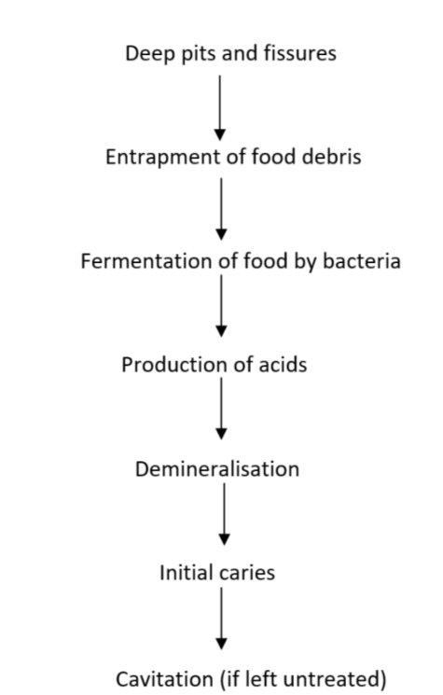
Figure 1The etiopathogenesis of pit and fissure caries.
Source (Ramamurthy et al., 2022)

3.2 Applications of Different Sealants
A. Resin-Based Sealants: Resin-based sealants have appeared exceptionally effective in preventing dental caries in children. Thinks have shown that they reduce caries rate by 76% after two to three years of application compared to no sealant teeth(Yengopal & Mickenautsch, 2010). The prevalent mechanical properties of resin-based sealants, such as high wear resistance and great maintenance rates, contribute to their viability. In any case, appropriate methods and keeping up a dry environment during application are significant for ideal results. They are mostly effective when applied soon after the eruption of permanent molars. (Mohanraj et al., 2019).
B. Glass Ionomer Sealants: Glass ionomer sealants are especially beneficial for high-risk populations, such as children who have trouble cooperating or in clinical circumstances where moisture control is challenging(Subramaniam et al., 2023). Even though they have lower maintenance rates than resin-based sealants, glass ionomer sealants still give caries assurance through their capacity to release fluoride. This fluoride discharge makes a difference in the remineralization of early carious teeth and gives an extra defence against decay. Considerations have appeared that glass ionomer sealants reduce the frequency of caries, even though their viability might be somewhat lower compared to resin-based options. (Simonsen, 1996).
C. Polyacid-Modified Gum Sealants (Compomers): Compomers, which combine components of both tar and glass ionomer sealants, offer direct protection against caries. They hold fluoride-releasing properties while too giving sensible maintenance rates compared to resin-based sealants. In clinical situations, compomer sealants have shown viable caries prevention, even though their performance may not outperform that of conventional resin-based sealants. They are regularly utilized in cases where both toughness and fluoride discharge are desired. (Puppin-Rontani et al., 2006).
D. Self-Adhesive Sealants: Even though moderately unused, self-adhesive sealants have appeared promising and have about in clinical cases due to their application management and reduced risk of contamination. Early proof recommends that they give a great level of caries reduction, even though prolonged clinical trials are necessary to completely evaluate their survival compared to more built-up sealant materials. (Bagherian et al., 2016).
E. Fluoride Discharging Sealants: Fluoride-releasing sealants are promising in reducing cavity formation in children and youths. These sealants altogether reduce the occurrence of carious formation, especially on the chewing surfaces of erupted molars, which are at risk of decay. (Ralph Rawls, 1986).
F. Temporary Sealant: Transitory sealants give a defensive layer over the occlusal (chewing) surfaces of molars, where children and adolescents are more prone to form caries. They are effective in reducing caries formation in the brief term, especially in patients who may not, however be candidates for more lasting sealants due to the condition of their teeth or the child's cooperation level. Considers propose that whereas brief sealants are successful at reducing decay in the brief term, they require regular checking and may require reapplication to keep up their defensive benefits. (Simonsen, 1996).
G. Coloured Sealant: Coloured or tinted dental sealants have picked up pace in paediatric dentistry due to their visual properties, which permit clinicians and caregivers to effortlessly screen the sealant's presence and keenness. These sealants are commonly utilised on the occlusal (chewing) surfaces of molars and premolars and are highly prone to developing dental cavities. The use of coloured sealants provides visual contrast that ensures complete coverage of pits and grooves, enhancing both the preparation for application and subsequent maintenance. They offer an extra advantage in terms of application viability and observation. The colour makes it simpler for dental experts to guarantee the sealant is connected appropriately and remains aligned over time, which is significant for long-term caries avoidance. (Ahovuo-Saloranta et al., 2017).
Table 1 highlights the strengths and limitations of various sealant materials for dental applications. The table compares various dental sealant materials based on their retention, fluoride release, moisture sensitivity, durability, and best use cases. Resin-based sealants offer high retention and durability but have low fluoride release and high moisture sensitivity, making them suitable for long-term protection in children with low to moderate risk of caries. Glass Ionomer Cement (GIC) has low retention and durability but excels in fluoride release and moisture tolerance, making it ideal for high-caries-risk children. Resin-Modified Glass Ionomer balances moderate properties and is suitable for moderate-risk children needing fluoride. Compomers (polyacid-modified resins) provide high retention and durability with moderate fluoride release, fitting for mixed-risk groups. Bioactive glass sealants, a newer material, offer very high fluoride release, low moisture sensitivity, and medium durability, making them beneficial for high-risk children, especially with early caries lesions.

Sealant Material | Retention | Fluoride release | Moisture sensitivity | Durability | Best use case
Resin-Based Sealants | High | Low (unless added) | High | High | Long-term protection in low-risk to moderate-risk children
Glass Ionomer Cement (GIC) | Low | High | Low | Low | High-caries-risk children, easier application for younger patients
Resin-Modified Glass Ionomer | Medium | High | Medium | Medium | Moderate-risk children needing fluoride release
Polyacid-Modified Resin (Compomer) | High | Moderate | Medium | High
  Mixed-risk populations need durability and some fluoride protection.
Bioactive Glass Sealants | Medium (new) | Very High | Low | Medium | High-risk children, especially with early caries lesions
Table 1 key Comparison of different sealants

This review explores the effectiveness of various dental sealants in preventing caries in children and adolescents. Dental caries is a widespread issue caused by bacterial acid production, and sealants play a key preventive role, especially on molars. Different sealants offer varying benefits: resin-based sealants provide high retention and durability but need dry conditions; glass ionomer sealants release fluoride and tolerate moisture well, making them suitable for high-risk children; resin-modified glass ionomers and compomers offer a balance of durability and fluoride release for moderate to mixed-risk groups; newer bioactive glass sealants show promising results for high-risk children with early lesions. Additional sealant types—like self-adhesive, temporary, and coloured sealants—offer practical advantages in specific clinical scenarios. Table 1 summarizes the performance of each material based on key criteria like retention, fluoride release, moisture sensitivity, and durability.

3.3 Study aims and objectives
This study aims to evaluate and compare the efficacy of various sealant materials in preventing dental caries in children and adults. Using the PICO format, the following research question was formulated:
· P: Children and adolescents at risk of dental caries.
· I: Various sealant materials.
· O: Prevention of dental caries.
- Objectives of the Systematic Review
- Comprehensive Literature Search
  - Systematically search and retrieve relevant literature from multiple electronic databases (e.g., PubMed, Google Scholar) and other reputable sources.
  - Include grey literature, reference lists of relevant articles, and possibly conference proceedings to ensure comprehensive coverage.
- Focus of Review
  - Identify studies evaluating the caries-preventive effectiveness of dental sealants in children and adolescents.
- Comparative Effectiveness Analysis
  - Compare the effectiveness of different types of dental sealants, including:
    - Resin-based sealants
    - Glass ionomer sealants
    - Fluoride-releasing sealants
  - Assess performance over a specified follow-up period to determine short-term and long-term benefits.
- Data Extraction
  - Extract relevant data from eligible studies, including:
    - Study characteristics (design, sample size, setting)
    - Participant demographics (age range, gender distribution, baseline oral health status)
    - Intervention details (type of sealant, application protocol, operator details)
    - Follow-up duration
    - Caries-related outcomes (incidence, progression, number of prevented lesions)
- Data Presentation
  - Present findings in structured tables for clear comparison across studies.
  - Provide descriptive summaries to highlight similarities, differences, and trends in the evidence.
- Evidence Synthesis
  - Use qualitative synthesis to integrate findings across studies, identifying patterns, consistencies, and contradictions in results.
- Critical Appraisal of Methodological Quality
  - Evaluate methodological quality and risk of bias for each included study using validated tools:
    - CASP Checklist for Randomised Controlled Trials (RCTs)
    - QUIN tool for non-randomised or quasi-experimental studies.
- Certainty of Evidence Assessment
  - Assess the overall certainty of evidence using an established framework.
- Identification of Knowledge Gaps
  - Highlight limitations in the current evidence base, such as:
    - Underrepresented age groups or populations
    - Lack of long-term follow-up data
    - Limited comparison between sealant types in certain contexts
- Recommendations for Future Research
  - Provide targeted suggestions to address gaps, enhance methodological quality, and improve the robustness of future studies on dental sealant effectiveness in paediatric and adolescent populations.

4. Methodology

4.1 Study design
This systematic review examines observational descriptive studies to evaluate the comparative effectiveness of various sealant materials in preventing dental caries among children and adolescents. The review aims to determine which materials provide the most effective and long-lasting protection by assessing critical performance characteristics, including retention rates, fluoride release capacity, overall durability under masticatory forces, and clinical suitability for patients across different caries risk profiles. In addition to comparing established materials such as resin-based and glass ionomer sealants, the review also considers advancements in newer formulations, thereby offering a comprehensive perspective on material performance in real-world clinical contexts. By synthesising these findings, this work seeks to inform evidence-based decision-making in paediatric dentistry and optimise preventive strategies tailored to individual patient needs.

4.2 Literature Search
The literature search was conducted using Boolean operators and MESH terms derived from keywords across different scientific databases such as PubMed and Google Scholar the research question, as outlined in Table 2 below.
SL. No | Domain | Keyword | Boolean Operators
1. | Problem | Dental caries. | ((“Dental caries”)) OR ((“Tooth decay”))
2. | Intervention | Various sealant materials. | ((“sealant”)) OR ((“Pits and fissure sealants”)) OR ((“Polyacid-Modified Gum Sealants”)) OR ((“Tooth Sealants”)) OR ((“Enamel Sealants”))
3. | Outcome | Prevention of dental caries and comparing the cost and durability of various sealants. | ((“Prevention of Tooth decay”)) OR ((“Caries control”)) OR ((“Oral health promotion”)) OR (("cost of sealants" OR "economic evaluation of sealants")) OR ("durability of sealants" OR "longevity of sealants")

Table 2 A literature search using Boolean operators

4.3 Mesh term used.
((“Dental caries”)) OR ((“Tooth decay”)) AND ((“sealant”)) OR ((“Pits and fissure sealants”)) OR ((“Polyacid-Modified Gum Sealants”)) OR ((“Tooth Sealants”)) OR ((“Enamel Sealants”)) AND ((“Prevention of Tooth decay”)) OR ((“Caries control”)) OR ((“Oral health promotion”))

4.4 Manual Search
In addition to the scientific server, I have manually searched the articles by reviewing the reference lists of the included works.

4.5 Literature selection
The article was chosen based on their inclusion and exclusion criteria. The article's title that matches the research question was taken, and the abstract was reviewed to see whether the article meets the inclusion and inclusion criteria, followed by reading the full article.

4.6 Inclusion and exclusion criteria
The inclusion criteria:
- children and adolescents (ages 3–18) who are at risk for dental caries.
- Studies that compare the efficacy of two or more types of sealant materials in preventing dental caries.
- Reports on caries incidence or progression, sealant retention rates, clinical studies and full-text articles.
The exclusion criteria:
- Non-comparative studies, case reports, or reviews.
- Studies without quantitative outcomes related to caries prevention, sealant retention and preclinical studies.

4.7 Screening stage
Articles were screened in three stages. First, they were screened based on their title. Then, they were screened based on their abstract. In the third stage, they were further screened by reading the full article and a PRISMA chart was made.

4.8 Outcome measures
Outcome measures for the efficacy of sealant materials in preventing dental caries in children and adolescents include the incidence of new caries, sealant retention rates, and overall effectiveness compared to no sealant.

4.9 Quality assessment
The selected studies underwent a rigorous critical appraisal process to ensure methodological robustness and reliability of findings. Validated assessment tools were employed, including the Critical Appraisal Skills Programme (CASP) checklist for Randomised Controlled Trials (RCTs) and the QUIN tool checklists for in vitro studies, to systematically evaluate each study’s quality. This appraisal considered multiple dimensions, such as the appropriateness and clarity of the methodology, the transparency and relevance of the inclusion and exclusion criteria, the validity and reliability of the outcome measures used, and the rigour of the data analysis methods. By applying these structured evaluation frameworks, the review ensured that only high-quality evidence contributed to the synthesis, thereby strengthening the validity and applicability of the conclusions drawn

4.10 Data extraction and management
From each included article, relevant data were systematically extracted to facilitate comparison and synthesis of findings. Key variables collected included the year the study was conducted, the name(s) of the author(s), total sample size, and details of the sealant materials evaluated. Information was also gathered on the comparative performance of different sealants, focusing on their effectiveness in preventing dental caries and their overall efficiency when applied to paediatric populations. Additional details, such as retention rates, follow-up duration, and specific outcomes reported, were also noted where available. These extracted data will be organised and presented in a comprehensive comparative table, enabling a clear side-by-side evaluation of the studies and highlighting similarities, differences, and trends across the included research.

4.11 Ethical Considerations
This study is a literature review of articles available in scientific databases. The ethics approval form was approved and submitted alongside the appendices.

5. Result

5.1 Literature Result Search
The PRISMA flow diagram (Figure .2). The literature search yielded a total of 4,562 records across PubMed and Google Scholar. Following the removal of 1,324 duplicates, 3,238 unique records underwent title screening, with 2,416 excluded for irrelevance to the research topic. The remaining 822 reports were sought for full-text retrieval, of which 57 could not be obtained due to access limitations. A total of 765 full-text articles were assessed for eligibility against predefined inclusion and exclusion criteria. Of these, 760 were excluded for reasons including non-comparative study design (n = 325), absence of a paediatric/adolescent population (n = 240), and lack of relevant outcome measures (n = 195). Ultimately, 5 studies met the eligibility criteria and were included in the review. This substantial narrowing from thousands of initial records highlights the rigorous selection process undertaken to ensure only the most relevant, methodologically sound studies were synthesised in the final analysis.
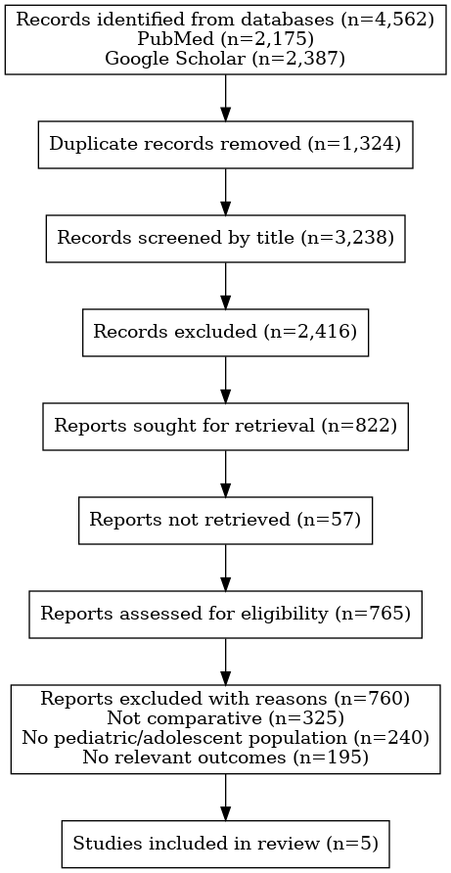
Figure 2 PRISMA Chart
5.2 Data Extraction
Data extraction was conducted from the five articles that met the inclusion criteria after the screening and eligibility assessment. For each study, key information was systematically collected, including authorship, year of publication, study design, type and brand of dental sealant applied, reported outcomes related to caries prevention, retention rates of the sealants, and relevant population characteristics such as age group or developmental stage.
The selection process excluded articles that did not provide full-text access, as well as systematic reviews, letters to the editor, commentaries, and studies deemed irrelevant based on their title or abstract. This ensured that only original research directly addressing the research question was included for detailed analysis

5.3 Summary of the Evidence
Table 3 summarises five studies evaluating various sealant and adhesive systems, each employing different study designs, target populations, and follow-up durations. Applying the CASP (Critical Appraisal Skills Programme) framework, it was evident that most studies adequately addressed the core question related to sealant retention, bond strength, or caries prevention, though the depth and applicability of their findings varied. Moura et al. (2014) approached the question through a controlled laboratory experiment involving both primary and permanent teeth, providing valuable insights into material performance under standardised conditions; however, the lack of an in vivo component limits the extrapolation of results to clinical settings where patient variables may significantly influence outcomes. Prathibha et al. (2019) tackled the question using a robust split-mouth clinical trial design, allowing for direct intra-patient comparison of materials. While methodologically strong, the study’s single-centre setting and relatively short follow-up period constrain the generalisability of the results across diverse populations and longer timeframes. Karaman et al. (2013) conducted a clinical trial assessing adhesive systems beneath sealants, yielding relevant findings for retention performance; nonetheless, the exclusive focus on adult teeth without paediatric participants limits the applicability of the results to the primary target group of this review. Mézquita-Rodrigo et al. (2022) did not fully address the clinical question, as their purely in vitro investigation utilised unerupted third molars, assessed only short-term outcomes, and did not include any direct measures of caries prevention. De Souza Penha et al. (2022) offered a mixed-methods approach, combining laboratory testing with short-term clinical application, which provided a more rounded perspective; however, the brief follow-up period was inadequate for evaluating the materials’ long-term caries-preventive capabilities. Overall, all studies except Mézquita-Rodrigo et al. (2022) directly addressed the review’s central question, though each exhibited methodological or contextual constraints that influence the strength, generalisability, and clinical applicability of their findings.
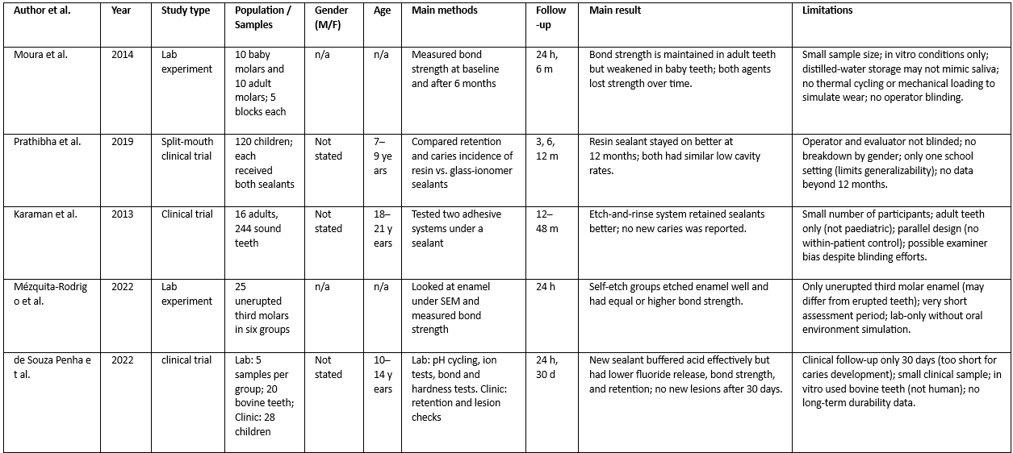
Table 3: Summary of Evidence

5.4 Critical Appraisal of Included articles
The following section provides a summary of the critical appraisals conducted for the included studies as a part of quality assessment process. The purpose of the appraisal was to assess the methodological rigor, reliability, and potential for bias in each study.
The checklist criteria addressed essential aspects, including:
- Clear definitions of inclusion criteria and sample selection
- Validity and reliability of measurements for both exposure and outcomes
- Application of appropriate statistical analysis
- Identification and management of confounding factors
- Consistency in measurement tools and the use of blinding
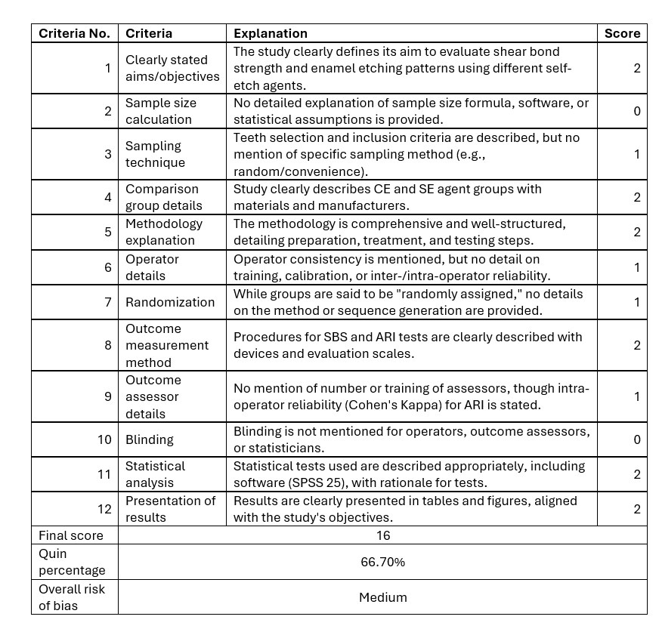
Table 4 QUIN Tool Appraisal Using -Self-Etch Adhesive Agents with Pit and Fissure Sealants.

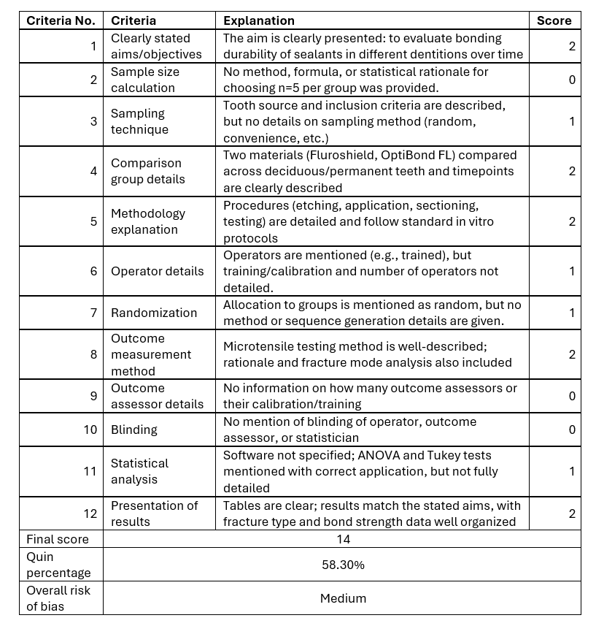
Table 5 QUIN Tool Appraisal for Bonding durability of dental sealants to deciduous and permanent teeth
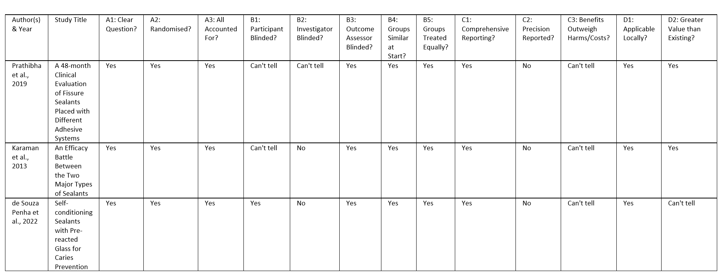
Table 6 CASP Appraisal of Three Studies
Legends
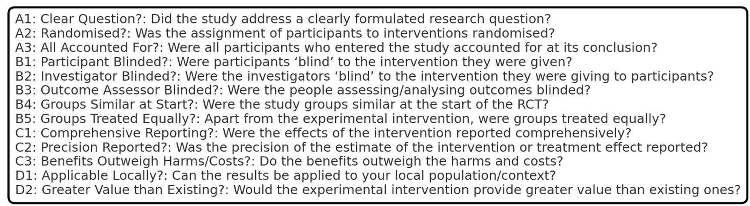

5.5 Summary of the Critical Appraisal of the Included Studies
Using the CASP and QUIN appraisal tools, each included study was assessed to determine whether it adequately addressed the central research question regarding the comparative caries-preventive effectiveness of different dental sealant materials in children and adolescents.
Y = Yes, N = No, ? = Can’t tell
Moura et al. (2014): Yes – This study directly addressed the research question by evaluating the bond strength and retention of different sealant materials under controlled laboratory conditions. However, the absence of an in vivo component limits the applicability of findings to clinical practice.
Prathibha et al. (2019): Yes – The study used a split-mouth clinical trial design to compare resin-based and glass ionomer sealants, providing relevant data on retention and caries prevention. Short follow-up duration was a limitation.
Karaman et al. (2013): No – While methodologically robust, the study focused exclusively on adult teeth without including paediatric or adolescent participants, meaning it did not fully address the target population for this review.
Mézquita-Rodrigo et al. (2022): No – This was a purely in vitro investigation using unerupted third molars and did not measure caries prevention outcomes, making it unsuitable for answering the central clinical question.
De Souza Penha et al. (2022): Yes – Combined laboratory and short-term clinical evaluation of sealant materials, directly addressing the research question. However, the short follow-up period limits conclusions about long-term effectiveness.
In summary, three of the five included studies (Moura et al., Prathibha et al., and De Souza Penha et al.) adequately addressed the research question, while two studies (Karaman et al., Mézquita-Rodrigo et al.) did not, due to either population mismatch or lack of direct caries-prevention data.

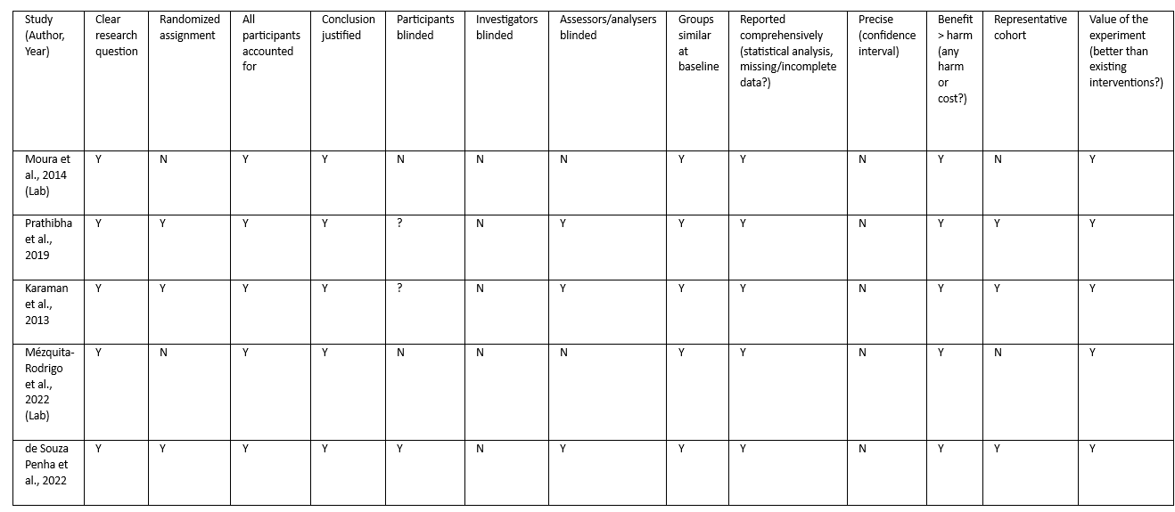
Table 7: Summary of the Critical Appraisal of the Included Studies

6. Discussion
Pit and fissure caries remain one of the most prevalent and persistent dental health challenges among children and adolescents worldwide, accounting for a significant proportion of occlusal surface decay in permanent molars (Ahovuo-Saloranta et al., 2017; Ramamurthy et al., 2022). These lesions arise primarily due to the complex anatomical morphology of pits and fissures, which often hinders effective mechanical cleaning and facilitates plaque accumulation, thereby increasing the risk of demineralisation and caries progression. Given the global emphasis on preventive dentistry, the use of sealants has emerged as a cornerstone strategy for protecting vulnerable tooth surfaces. This review is particularly important as it consolidates and critically appraises current evidence on the comparative efficacy of different sealant materials, including both conventional and novel formulations. In doing so, it offers clinicians practical, evidence-based guidance for selecting the most appropriate material according to patient-specific risk factors, tooth anatomy, and clinical setting. By evaluating the relative strengths and limitations of established and emerging sealant technologies, this work addresses a key gap in the literature and supports the development of targeted, cost-effective interventions aimed at reducing the worldwide burden of caries in paediatric and adolescent populations.
The analysis indicated that resin-based sealants, particularly when used with etch-and-rinse adhesives, demonstrated the highest retention rates and mechanical resilience (Mohanraj et al., 2019; Uzel et al., 2022). This superior performance is largely attributed to their micromechanical bonding to enamel, which provides a strong and durable interface capable of withstanding masticatory forces over extended periods. Glass ionomer cements (GICs), while showing lower retention, offered the advantage of sustained fluoride release, which can contribute to the remineralisation of adjacent enamel and the inhibition of bacterial activity. Their chemical adhesion to tooth structure, combined with better tolerance to moisture, makes them particularly useful in clinical situations where complete isolation is challenging, such as with partially erupted molars or in uncooperative paediatric patients (Subramaniam et al., 2023). Resin-modified glass ionomers (RMGICs) represented a middle ground, offering intermediate retention while combining the fluoride release of GICs with improved mechanical properties derived from their resin content. Notably, Prathibha et al. (2019) observed that similar caries-preventive outcomes were achieved by both resin and GIC sealants, suggesting that clinical factors beyond retention—such as the patient’s oral hygiene practices, dietary habits, and regular dental follow-up—play a critical role in determining long-term success. Emerging materials, such as bioactive glass sealants, have shown potential for enhanced remineralisation due to their ability to release multiple ions, including calcium and phosphate, which are essential for enamel repair. However, despite these promising laboratory results, robust, long-term clinical validation in diverse patient populations is still lacking (Ng et al., 2023).
These findings align closely with the conclusions of major systematic reviews in the field. The Cochrane review by Ahovuo-Saloranta et al. (2017) confirmed that resin-based sealants demonstrate superior retention compared with glass ionomer cements (GICs), while also emphasising that both materials significantly reduce the incidence of caries when compared with no sealant application. Similarly, Wright et al. (2016) found that all types of sealants were effective in preventing occlusal caries, stressing that the optimal choice of material should be guided by the specific clinical circumstances and needs of the patient. An umbrella review by Amend et al. (2024) further reinforced the importance of patient-centred material selection, noting that in high-caries-risk populations, the benefits of moisture-tolerant or fluoride-releasing sealants may outweigh the disadvantage of lower retention rates. Complementary evidence from laboratory-based investigations, such as Moura et al. (2014) and Mézquita-Rodrigo et al. (2022), supports the superior bond strength properties of resin-based sealants. However, these in vitro models, while useful for controlled comparisons, are limited in their ability to replicate the complex variables of the oral environment, such as saliva dynamics, masticatory forces, and patient compliance, which may influence long-term clinical performance.
Overall, the appraisal indicates that while the included studies addressed clearly defined research questions and generally maintained baseline comparability between groups, there were consistent methodological limitations. The most frequent issues were incomplete or absent blinding of participants and operators, insufficient detail on randomisation procedures, and short follow-up durations that limit assessment of long-term caries prevention.
Laboratory studies offered precise control over experimental variables but lacked the complexity of the oral environment, reducing direct clinical applicability. Clinical trials provided real-world insights but were often constrained by small sample sizes and limited geographic diversity, affecting the generalisability of results. No study met all criteria for a low risk of bias; most were graded as having some concern under the Cochrane RoB 2 framework.
Despite these limitations, the collective findings suggest a consistent pattern: resin-based sealants, particularly with etch-and-rinse adhesives, demonstrate superior retention and bond strength, while glass ionomer sealants remain valuable in high-caries-risk or moisture-compromised clinical scenarios. Emerging materials such as bioactive glass sealants show promise, but require robust, multicentre trials with extended follow-up to confirm their clinical efficacy and cost-effectiveness.

6.1 Limitations
This review is limited by the small number of eligible studies (n = 5), which restricts the breadth of comparative analysis. The included studies varied significantly in design, population age range, outcome measures, and follow-up periods, making meta-analysis impractical. A substantial proportion of data originated from in vitro studies, which lack full applicability to the clinical environment due to the absence of variables such as saliva, occlusal forces, and temperature fluctuations.
Moreover, several studies had methodological constraints, including the absence of blinding, non-randomised allocation, limited demographic diversity, and incomplete reporting of statistical parameters such as confidence intervals. Publication bias cannot be excluded, as studies with negative or inconclusive results may be underrepresented in the literature. Additionally, the exclusion of non-English publications may have resulted in language bias.

6.2 Future Research Directions
Future investigations should prioritise large-scale, multicentre, randomised controlled trials with standardised outcome measures and extended follow-up (≥5 years) to capture long-term performance and caries-preventive effects of sealants. Direct head-to-head comparisons of newer materials—such as bioactive glass, self-adhesive, and high-fluoride-release sealants—against established resin-based and glass ionomer sealants are warranted.
Further research should also explore the cost-effectiveness of different sealant materials in public health settings, particularly for high-risk paediatric populations. Incorporating patient-reported outcomes, such as comfort and acceptability, alongside clinical indicators, would provide a more holistic understanding of material success. Additionally, studies simulating real-world conditions—accounting for factors such as moisture contamination, partial eruption, and varying operator experience—are needed to bridge the gap between laboratory efficacy and clinical effectiveness.

7. Conclusion
This systematic review found that resin-based sealants generally offer the highest retention and long-term caries-preventive effectiveness, particularly when optimal moisture control is achievable. Glass ionomer sealants, while less durable, provide fluoride release and are suitable for high-caries-risk or moisture-compromised situations. Resin-modified glass ionomers offer a balance between retention and fluoride release, while bioactive sealants show promising laboratory results but require further long-term clinical research. Sealant selection should be patient-specific, based on caries risk, eruption stage, and clinical conditions, and integrated into a comprehensive preventive care plan.

8. References
Ahovuo‐Saloranta, A., Forss, H., Walsh, T., Hiiri, A., Nordblad, A., Mäkelä, M. and Worthington, H.V., 2013. Sealants for preventing dental decay in the permanent teeth. Cochrane Database of Systematic Reviews, (CD001830.pub4). https://doi.org/10.1002/14651858.CD001830.pub4
Ahovuo‐Saloranta, A., Forss, H., Walsh, T., Nordblad, A., Mäkelä, M. and Worthington, H.V., 2017. Pit and fissure sealants for preventing dental decay in permanent teeth. Cochrane Database of Systematic Reviews, 7(7), CD001830. https://doi.org/10.1002/14651858.CD001830.pub5
Amend, S., Boutsiouki, C., Winter, J., Kloukos, D., Frankenberger, R. and Krämer, N., 2024. Clinical effectiveness of pit and fissure sealants in primary and permanent teeth of children and adolescents: An umbrella review. European Archives of Paediatric Dentistry, 25(3), pp.289–315. https://doi.org/10.1007/s40368-024-00876-9
Azarpazhooh, A. and Main, P.A., 2008. Pit and fissure sealants in the prevention of dental caries in children and adolescents: A systematic review. Journal (Canadian Dental Association), 74(2), pp.171–177.
Bagherian, A., Sarraf Shirazi, A. and Sadeghi, R., 2016. Adhesive systems under fissure sealants: Yes or no? Journal of the American Dental Association, 147(6), pp.446–456. https://doi.org/10.1016/j.adaj.2016.01.014
Clarkson, J.E. et al., 2013. IQuaD dental trial; improving the quality of dentistry: A multicentre randomised controlled trial comparing oral hygiene advice and periodontal instrumentation for the prevention and management of periodontal disease. BMC Oral Health, 13(1), p.58. https://doi.org/10.1186/1472-6831-13-58
Colak, H., Dülgergil, C.T., Dalli, M. and Hamidi, M.M., 2013. Early childhood caries update: A review of causes, diagnoses, and treatments. Journal of Natural Science, Biology, and Medicine, 4(1), pp.29–38. https://doi.org/10.4103/0976-9668.107257
Duijster, D., Verrips, G.H.W. and Van Loveren, C., 2014. The role of family functioning in childhood dental caries. Community Dentistry and Oral Epidemiology, 42(3), pp.193–205. https://doi.org/10.1111/cdoe.12079
Karaman, E. et al., 2013. A 48-month clinical evaluation of fissure sealants placed with different adhesive systems. Operative Dentistry, 38(4), pp.369–375. https://doi.org/10.2341/12-181-C
Fejerskov, O., 1997. Concepts of dental caries and their consequences for understanding the disease. Community Dentistry and Oral Epidemiology, 25(1), pp.5–12. https://doi.org/10.1111/j.1600-0528.1997.tb00894.x
Gray, S.K., Griffin, S.O., Malvitz, D.M. and Gooch, B.F., 2009. A comparison of the effects of toothbrushing and handpiece prophylaxis on retention of sealants. Journal of the American Dental Association, 140(1), pp.38–46. https://doi.org/10.14219/jada.archive.2009.0016
Lee, J. et al., 2022. Oral health status and oral health-related quality of life of First Nations and Metis children. JDR Clinical and Translational Research, 7(4), pp.435–445. https://doi.org/10.1177/23800844211037992
Marinho, V.C., Higgins, J.P., Sheiham, A. and Logan, S., 2003. Fluoride toothpastes for preventing dental caries in children and adolescents. Cochrane Database of Systematic Reviews, 2003(1), CD002278. https://doi.org/10.1002/14651858.CD002278
Mohanraj, M., Prabhu, R., Thomas, E. and Kumar, S., 2019. Comparative evaluation of hydrophobic and hydrophilic resin-based sealants: A clinical study. Journal of Contemporary Dental Practice, 20(7), pp.812–817.
Muntean, A., Simu, M.R., Suhani, R. and Mesaros, A.S., 2019. Pit and fissure sealants' penetration capacity and their correlation with fissure morphology. Medicine and Pharmacy Reports, 92(Suppl 3), pp.S50–S54. https://doi.org/10.15386/mpr-1517
Ng, T.C.H., Chu, C.H. and Yu, O.Y., 2023. A concise review of dental sealants in caries management. Frontiers in Oral Health, 4, 1180405. https://doi.org/10.3389/froh.2023.1180405
Niederman, R., 2010. Glass ionomer and resin-based fissure sealants – equally effective?: Are glass ionomer cements as effective as resin-based fissure sealants when used on permanent teeth? Evidence-Based Dentistry, 11(1), p.10. https://doi.org/10.1038/sj.ebd.6400700
Peres, M.A. et al., 2019. Oral diseases: A global public health challenge. The Lancet, 394(10194), pp.249–260. https://doi.org/10.1016/S0140-6736(19)31146-8
Petersen, P.E., Bourgeois, D., Ogawa, H., Estupinan-Day, S. and Ndiaye, C., 2005. The global burden of oral diseases and risks to oral health. Bulletin of the World Health Organization, 83(9), pp.661–669.
Puppin‐Rontani, R.M., Baglioni‐Gouvea, M.E., de Goes, M.F. and Garcia‐Godoy, F., 2006. Compomer as a pit and fissure sealant: Effectiveness and retention after 24 months. Journal of Dentistry for Children (Chicago, Ill.), 73(1), pp.31–36.
Rawls, H.R., 1986. Fluoride-releasing acrylics. Journal of Biomaterials Applications, 1(4), pp.382–405. https://doi.org/10.1177/088532828600100406
Ramamurthy, P. et al., 2022. Sealants for preventing dental caries in primary teeth. Cochrane Database of Systematic Reviews, 2022(2). https://doi.org/10.1002/14651858.CD012981.pub2
Selwitz, R.H., Ismail, A.I. and Pitts, N.B., 2007. Dental caries. The Lancet, 369(9555), pp.51–59. https://doi.org/10.1016/S0140-6736(07)60031-2
Sheiham, A. and James, W.P.T., 2015. Diet and dental caries: The pivotal role of free sugars reemphasized. Journal of Dental Research, 94(10), pp.1341–1347. https://doi.org/10.1177/0022034515590377
Silverstone, L.M., 1982. The use of pit and fissure sealants in dentistry, present status and future developments. Pediatric Dentistry, 4(1), pp.16–21.
Simonsen, R.J., 1996. Glass ionomer as fissure sealant—A critical review. Journal of Public Health Dentistry, 56(3), pp.146–149. https://doi.org/10.1111/j.1752-7325.1996.tb02425.x
Subramaniam, P., Kiran, K. and Vojjala, B., 2023. Comparison of clinical efficacy of glass ionomer-based sealant using ART protocol and resin-based sealant on primary molars in children. International Journal of Clinical Pediatric Dentistry, 15(6), pp.724–728. https://doi.org/10.5005/jp-journals-10005-2450
Uzel, I., Gurlek, C., Kuter, B., Ertugrul, F. and Eden, E., 2022. Caries-preventive effect and retention of glass-ionomer and resin-based sealants: A randomized clinical comparative evaluation. BioMed Research International, 2022, pp.1–7. https://doi.org/10.1155/2022/7205692
Wong, A., Subar, P.E. and Young, D.A., 2017. Dental caries. Advances in Pediatrics, 64(1), pp.307–330. https://doi.org/10.1016/j.yapd.2017.03.011
Wright, J.T. et al., 2016. Sealants for preventing and arresting pit-and-fissure occlusal caries in primary and permanent molars. Journal of the American Dental Association, 147(8), pp.631–645.e18. https://doi.org/10.1016/j.adaj.2016.06.003
Yengopal, V. and Mickenautsch, S., 2010. Resin-modified glass-ionomer cements versus resin-based materials as fissure sealants: A meta-analysis of clinical trials. European Archives of Paediatric Dentistry, 11(1), pp.18–25. https://doi.org/10.1007/BF03262705

9. Appendix
